Pica Information sheet

What is Pica?
The origin of the word ‘Pica’ pronounced ‘PIE-kuh’ comes from the Latin word for the bird known as the magpie. As these birds are known for eating substances unfit for consumption as first described by Ambrose Pare (1509-1590). Pica is commonly described as repeated consumption or craving of/ for inedible or non-food items that hold no nutritional value. Children may eat one specific non-edible items or lots of different ones.
However, children approximately between the ages of 18-24 month may try to eat items that are not considered edible or food. This is not necessarily a sign or considered as ‘Pica’ but exploration of new objects.
Also taking into consideration cultural norms – in some culture’s consumption of various non-food items, is seen as a social ‘norm’ e.g., some cultures promote eating clay as part of a medicinal practice.

What causes Pica?
It’s quite unclear as to what causes Pica, there are many theories surrounding Pica which appear to overlap. Yet, there are some conditions that can increase the chances of developing Pica. Ali (2001) estimates between 4% and 25% of children who develop Pica have developmental difficulties. Along with;

- Learning disabilities (not moving on from early years, still seeking the development of mouthing items for comfort and satisfaction.)
- Autism (There are several reasons an individual with ASD might develop Pica for example seeking sensory input, being unable to differentiate between what is edible and what is not, deficiencies, self-soothing.)
- A diet that is lacking in iron or zinc - in an attempt to correct the balance, a craving of inedible items has been associated with Pica tendencies. (Visit GP to rule these causes out.)
- Sensory (some children can feel drawn to items with some sensory characteristics which are pleasing/satisfying. For example; certain smells, tastes and textures. Thus, a child associates this eating behaviour with satisfaction – Research highlighted children eating cigarette butts are reinforcing the behaviour from the nicotine).
- Emotional regulation – anxiety can drive a child to seek objects to chew or suck in an attempt to self sooth and create a sense of comfort enabling them to self-regulate to an optimal zone of arousal.

What does Pica look like?
Pica behaviour will be present for a minimum of a month and is no longer appropriate of their developmental stage for the child. Some examples of items;
- Soil, clay, glass, sand, chalk
- Plasters
- Clothing
- Stones
- Coins
- Ice
- Hair, fluff
- Paint chips, plaster, glue
- Buttons, paperclips
- Paper
- Baking soda
- Pencils, pencil shavings
- Coffee grounds
- Toothpaste, soap
- Faeces, drinking urine

What are the risks of pica?
Most objects can pass through a child’s body with no harm. However, some risks include;
- Choking
- Poisoning
- Vomiting
- Constipation
- Blockages in the gut and intestines
- Infections
- While some evidently pose a risk to the health and safety of a child another implication could be social isolation due to behaviours related to Pica that peers may deem as strange and unusual.

Some strategies to safely satisfy Pica.
- Pica Box – This can be a great way of offering a child alternative food that are edible but also have similar textures in order to replace the non-food items. A valuable online resource can be found where occupational therapist Rachel Peek gives advice about Pica boxes and their use please see link below.
(https://www.togethertrust.org.uk/news/together-trust-occupational-therapist-steps-tackle-eating-disorder-vulnerable-children)
Rachel Peek also gives strategies on how to use the box. For example, she put a picture of the child with a brief explanation of the intended use of the box. She labelled the edible items with non-edible names see pictures below for more detail (Searls 2020).

Success storey
Rachel Peek goes on to describe her success with the box and the positive feedback she has received from teachers and teachers’ assistance. One story in particular can be found on the web page accessed from the URL link above, detailing a child who was offered a celery stick as she was eating a twig, when she was finished with the celery, she tapped the box for more. Furthermore, the child lost all interest in nonedible and would instead go directly for the box. She also utilised Velcro stickers to allow the child to pick which food item they wanted.

Food replacement ideas –
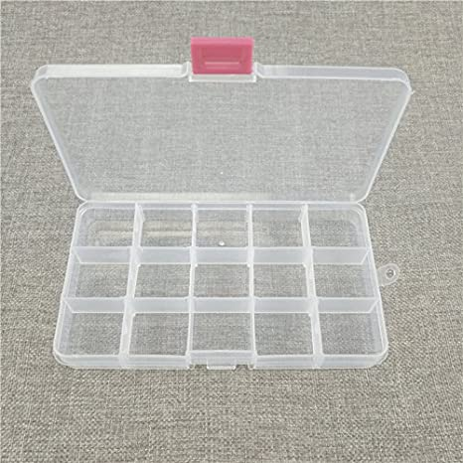
Box similar to these could be used to store the items of food – along with putting the child’s photo on the top and maybe some Velcro stickers

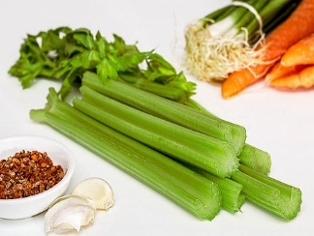
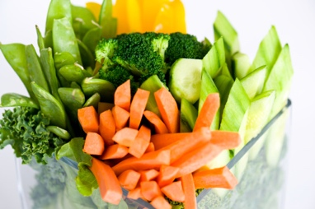
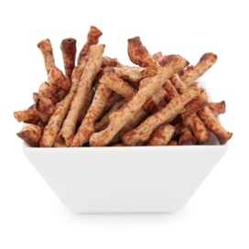
Celery, twiglets and vegetable sticks substituting twigs.

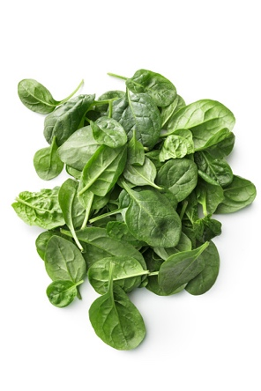
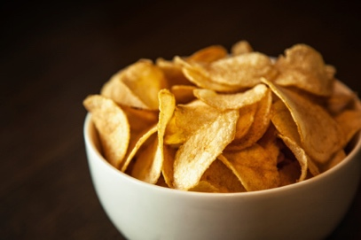
Crisps and spinach leaves substituting tree leaves.

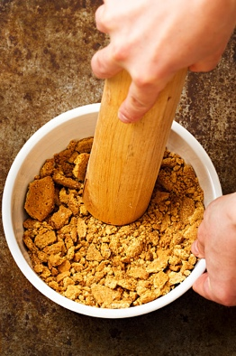

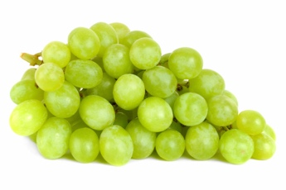
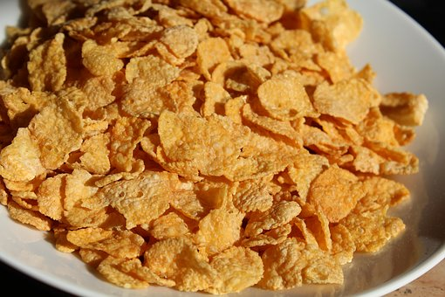
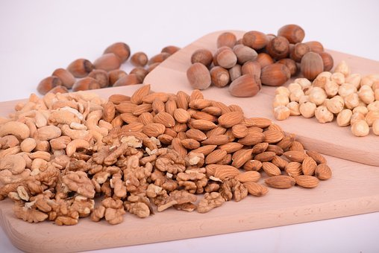
Crushed biscuits, grapes, nuts and corn flakes substituting sand, dirt, rocks and gravel.

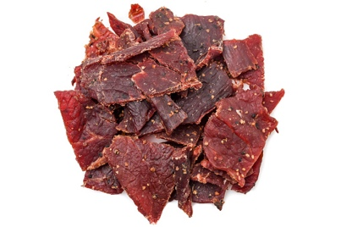

Beef jerky substituting bark and twigs

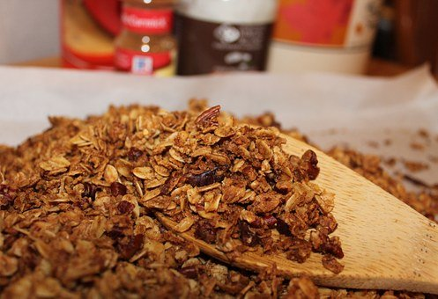

Granola substituting gravel, dirt and rocks.

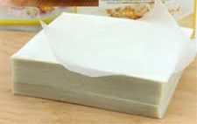

Rice paper substituting paper.

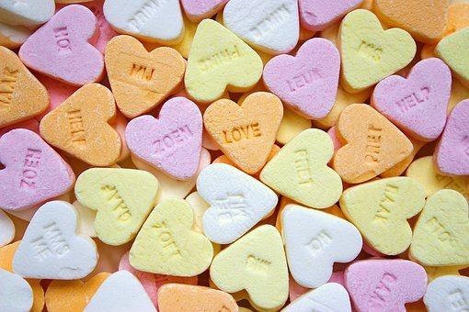

‘Love hearts’ substituting chalk.

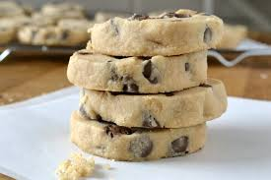
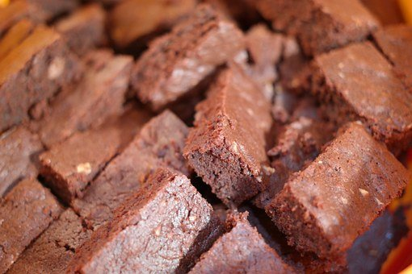

Edible cookie dough and soft brownie substituting faeces. (ensure these are given in moderation - smaller sizes)

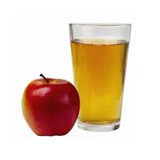
Apple juice substituting urine.

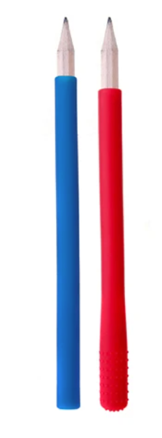
Other strategies are chewable objects – see below for some ideas.

Chewable pencil toppers.

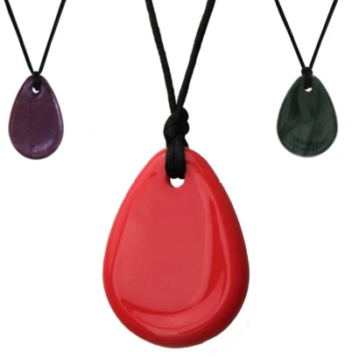
Necklaces chew jewellery.

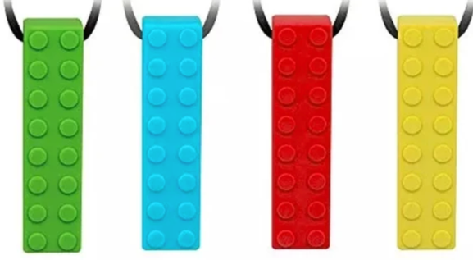

Lego chew Jewellery.

The chewable jewellery comes in all different shapes, sizes and colours. These can be purchased from online stores – if you type into a search engine ‘chewable jewellery’. Or if you’re looking for a more specific chewable object type in for example ‘Lego chewable jewellery’.
Another idea - print out and laminate prompt cards as mentioned above, for the child to give when wanting to engage in Pica behaviour for example, leaves, bark, sand, rocks, gravel and twigs;
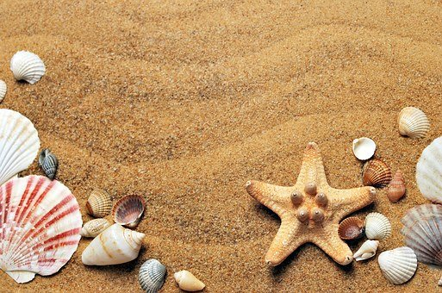


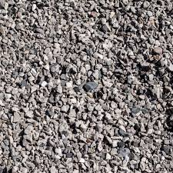

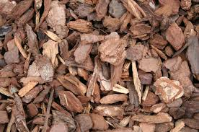

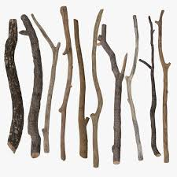

Some other strategies

- Making the environment safe, ensuring that steps are taken to remove items that present a risk from school/ home setting. This may look like carrying out a risk assessment of the environment removing objects, setting boundaries and restricting areas.

- Positive reinforcement, implementing a reward system when an inedible object is resisted.

- Environment of a social nature, ensuring the child is participating socially and having a sufficient level of interaction and ensure participation in physical activities and an optimal level of sensory stimulation i.e using safe toys for sensory stimulation such as chewable jewellery that cannot be swallowed.

- Discrimination techniques, teaching the child to be able to discriminate between objects that are edible and those that are not. Encouragement of pausing to really think about what they are putting in their mouth and help the child to consider if the item picked is to be eaten or discarded.
References;
Searls, A., 2020. Together Trust Occupational Therapist Steps Up To Tackle Eating Disorder In Vulnerable Children | Together Trust. [online] Togethertrust.org.uk. Available at: <https://www.togethertrust.org.uk/news/together-trust-occupational-therapist-steps-tackle-eating-disorder-vulnerable-children> [Accessed 6 November 2020].
Mace, F. C., & Knight, D. 1986. Functional Analysis and Treatment of Severe Pica. Journal of Applied Behavior Analysis. 19, 411-416.
Dudley, R., Ahlgrim-Delzell., L and Calhoun, M. (1999) Diverse diagnostic and behavioural patterns amougst people with a dual diagnosis. Journal of Intellectual Disability Research, 43, 70-79.
Searls, A. 2020. Together Trust Occupational Therapist Steps Up To Tackle Eating Disorder In Vulnerable Children | Together Trust [Online]. Available at: https://www.togethertrust.org.uk/news/together-trust-occupational-therapist-steps-tackle-eating-disorder-vulnerable-children [Accessed: 23 November 2020].

