Using J2E to access work
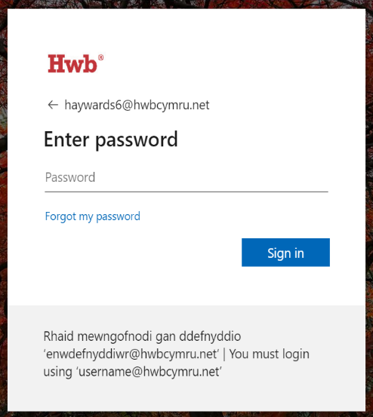
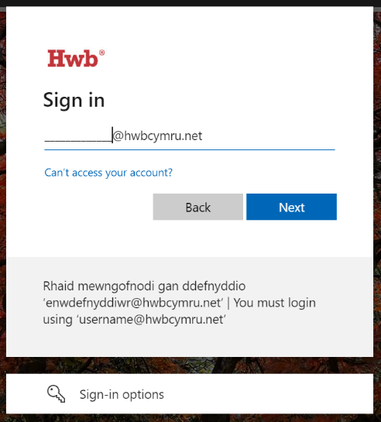
1. Log into HWB with username (email address) and password.

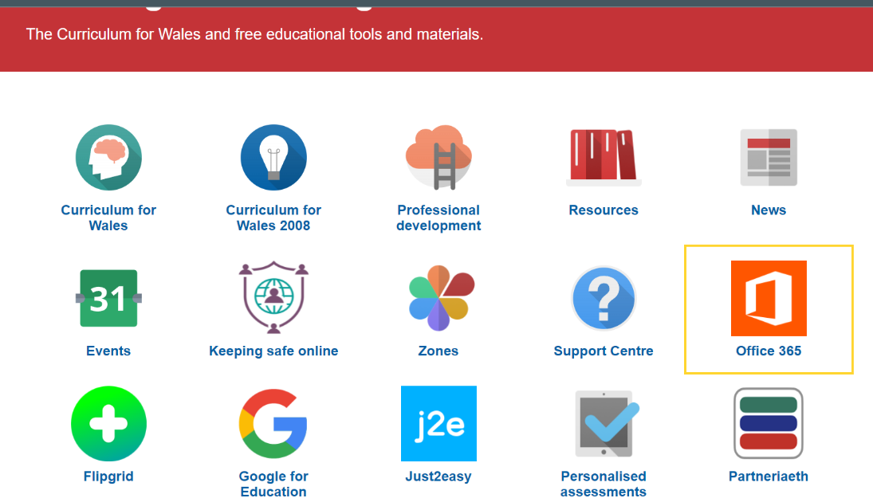
2. Click on ‘Just2easy’.

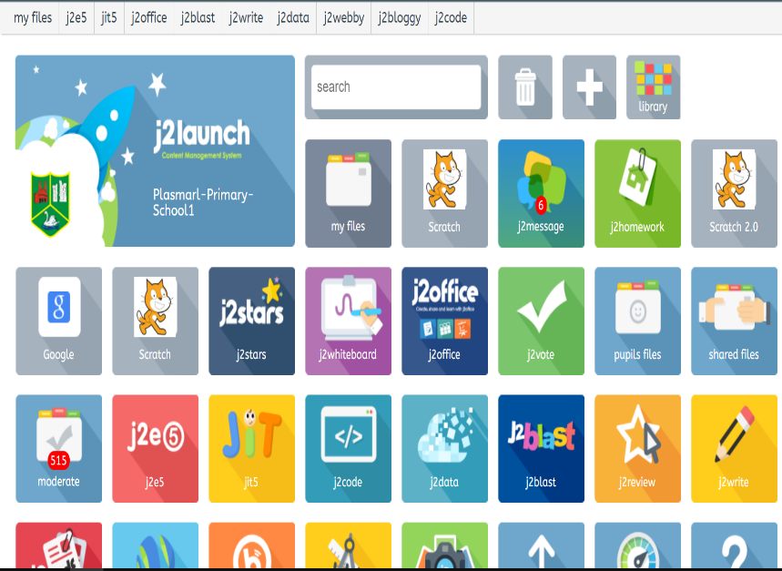
3. Click on ‘My Files’. Then choose ‘Shared Files’.
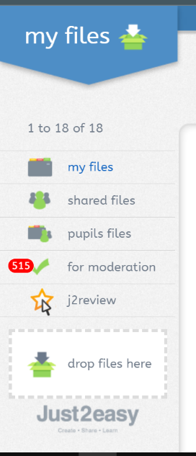

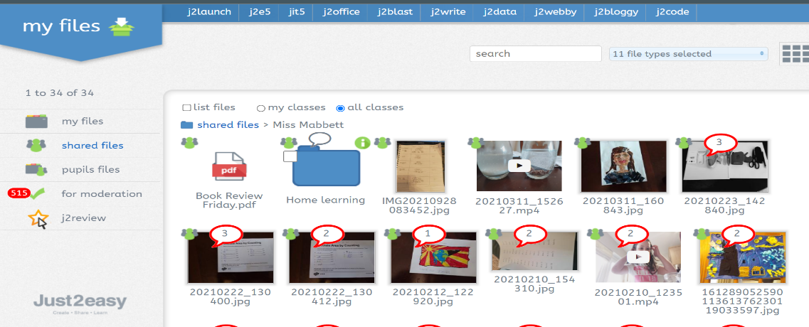
4. Then click on your child’s teacher. Choose ‘Home Learning’ and select the Week Beginning that corresponds to the correct date.

5. Once you have found the work, click on the green ‘i’ and choose the option ‘use in J2e’.
6. When the work has been completed, click the save option at the top of the page. This is the third option from the left (if you hover over it, it will say ‘save’). This will save it into your files.

