Using Microsoft Teams to access work
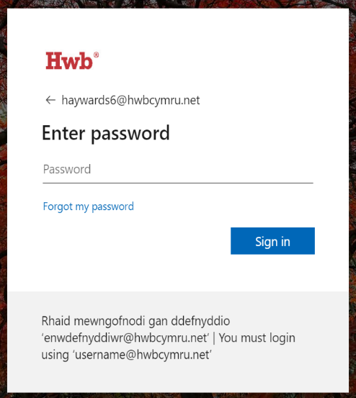
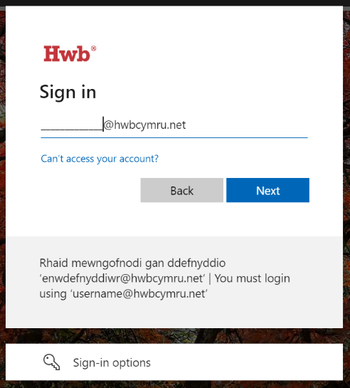
1. Log into HWB with username (email address) and password.

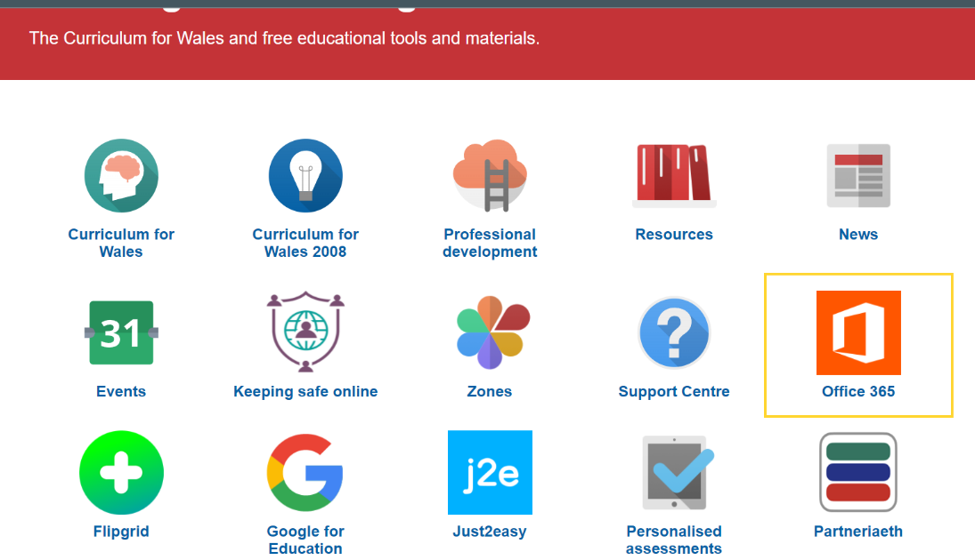
2. Click on ‘Office 365’.

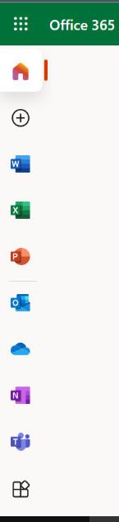
3. Click on ‘Teams’ on the left hand side of the page.

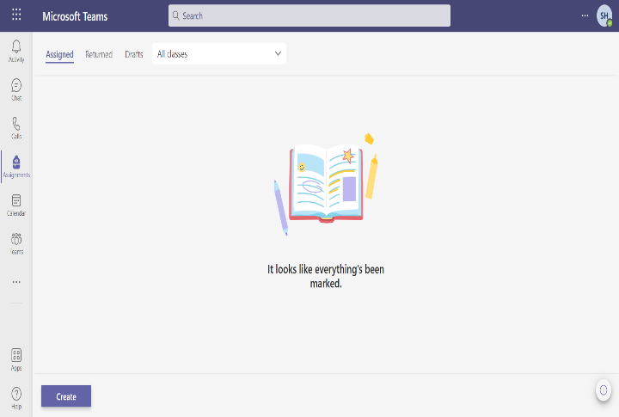
4. Choose the ‘Teams’ option and then click on your class. Click on the files option.
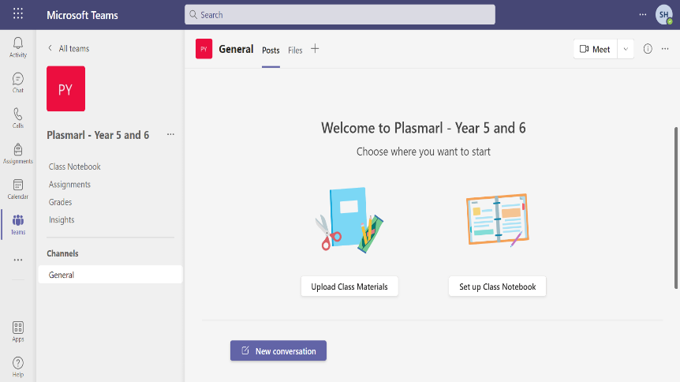

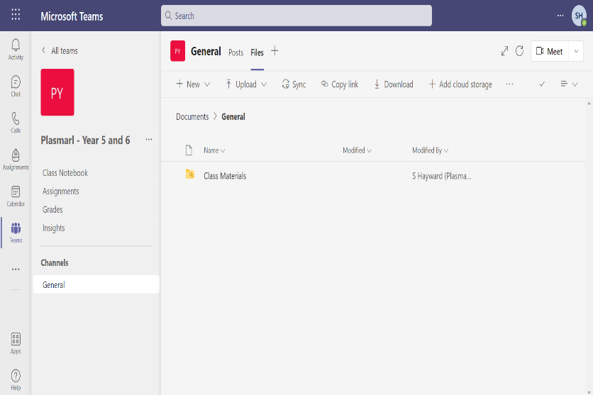
5. Click on ‘Class Materials’ and choose the file with the corresponding date.
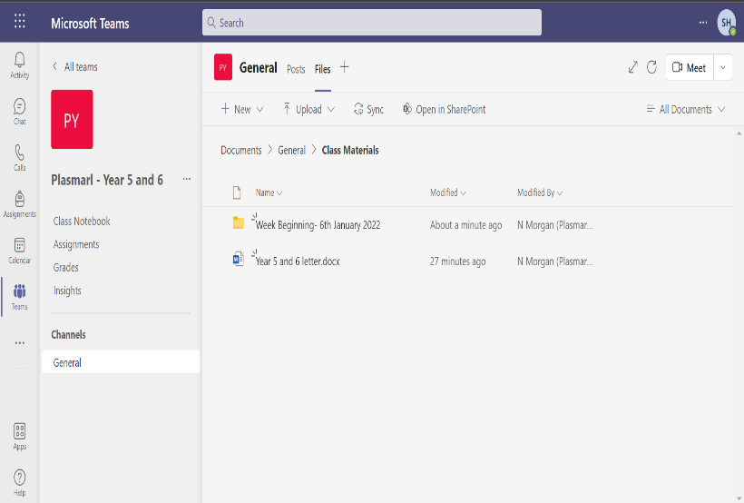

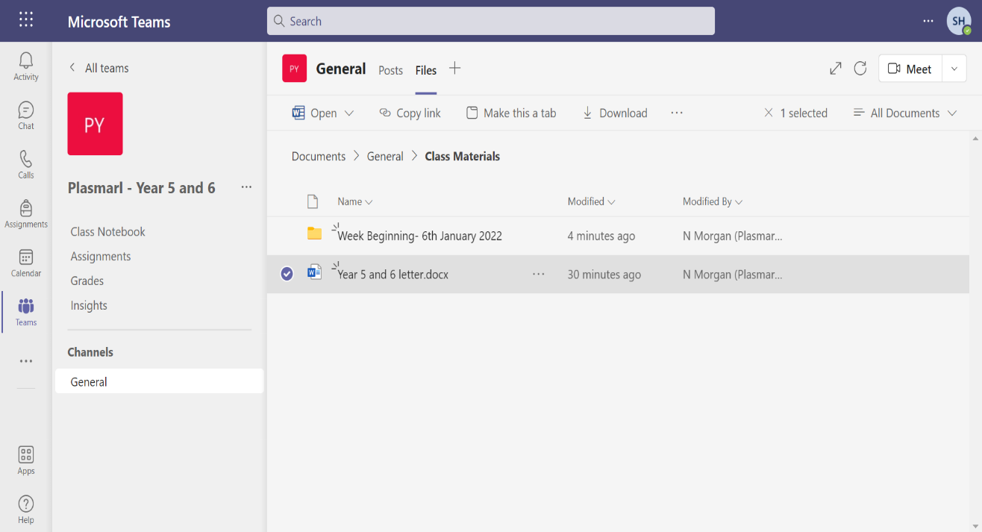
6. Tick the file that you are going to complete and then click download it.

2

1
7. Save the file onto your desktop (home page of your laptop). Once saved, open the document and your child can complete the work set. Once completed, save it on the desktop as it originally was (just update the saved document).
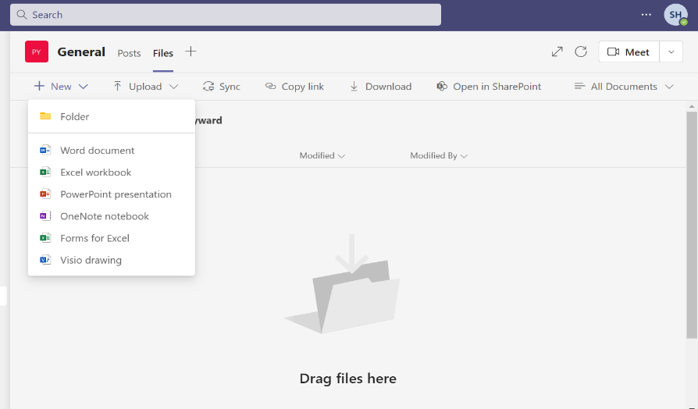
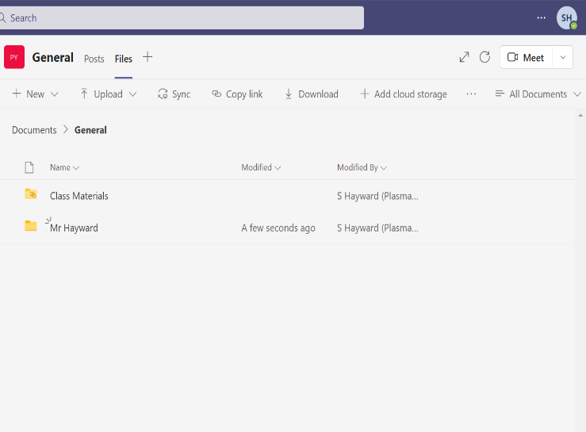
8. Open your child’s file on Teams. Create a folder with the Week Beginning date. Do this by clicking ‘New’ and then ‘Folder’.

9. Click on ‘Upload’ and then click ‘File’. Locate the file on your desktop and then upload it.
