Stress and parenting

- What is stress
- Causes of stress
- Stress Busting


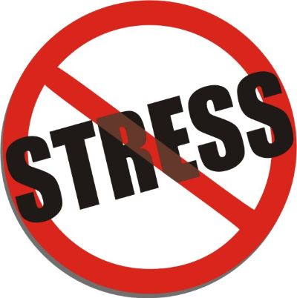

What is stress?

The most common form of stress is a mix of anxiety (tension, nerves) and low mood (feeling flat, sad). It often comes with sleep problems, panic feelings and anger.

Stress is not a black and white thing. We all worry and we all feel down from time to time. Stress itself is not a problem. It depends on how much stress and it should cause concern when it does not die down and when it affects us at a time when we know it should not. This could be sitting watching TV, talking to friends, walking to shops etc.

It becomes a problem when we feel we can’t control it. It comes about when the pressure on us outweighs our ability to cope.
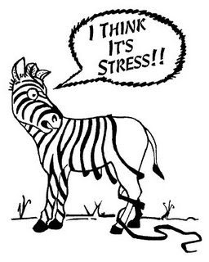
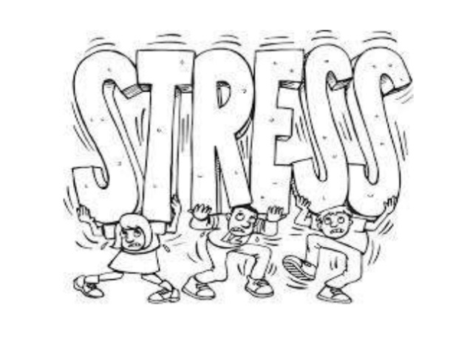

The cause of stress
Many things can cause stress. Some people find it hard to work out why they have stress. It is often caused by more than one thing. These can include…

Your nature: Childhood years
- Those who had a lot of childhood fears (often in the first two years of life)
- Not having a stable, secure loving upbringing
- Being wrapped in cotton wool by a parent
- Coped with stress by avoiding facing problems
- Having lots of changes in you r life – moving house, schools, illness in you or others close to you, parents separating ect.

Adult years
If, by nature, you are easily upset, often tense, prone to low moods, worry, often dissatisfied with yourself and others, feel guilty keenly, then you may be more prone to stress.

Other adult factors that make you prone to stress as an adult are:
Life events – the more changes in life, the more prone most of us become to stress. Good events (birth of a baby, getting a job, moving area) as well as bad events (bereavement, losing job) can trigger stress. This is due to having to adjust to change. If you have to cope with too much change, stress can result.


Social factors – there is a clear link between stress and social factors:
- Money problems
- Being a single parent
- A lack of control over your life
- Poor education
- Poorer health
- Not having support from others
Due to masculine attitudes, men may be better at hiding stress. Men may also drink alcohol as a way of coping with stress. Men are three times more likely to have a problem with drink as women. So men might start off with a stress problem, drink to control it and end up with a drink problem that is really hiding stress.

Once stress gets a grip
- Self-confidence drops
- Self-esteem drops
- You feel threat from all sides
- You doubt your ability to cope
- You can’t stop your mind racing
- You start to avoid facing up to stress
- You body reacts easily to stress
- You may feel your back is to the wall
- You may feel the stress brings out the worse in you
- You feel you can’t control your life

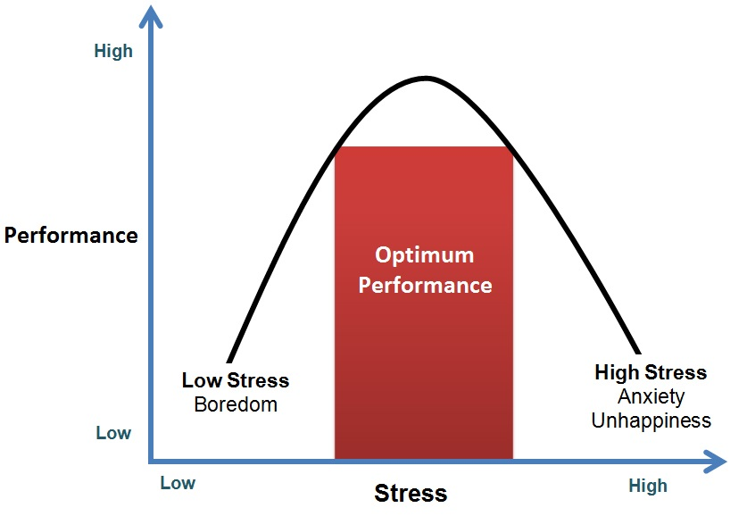

My Stressors

Circle Of Influence, Circle Of Concern

There’s a diagram in Steven Covey’s book The 7 Habits of Highly Effective People that I always try to keep in mind. It looks like this:

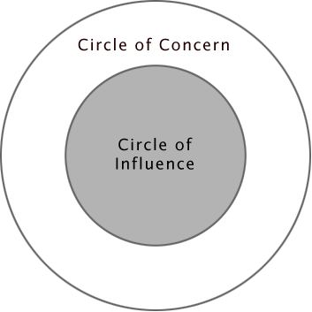

The circles represent the two areas where you can focus your time and energy. The vast majority of people focus too much time and energy outside of their Circle of Influence, in their Circle of Concern. Such people typically worry about things they cannot control, such as the weather next weekend or war in the Middle East.
Preoccupying yourself with issues like that is a huge waste of time and energy.

Source: https://ndoherty.com/circle-of-influence-circle-of-concern/
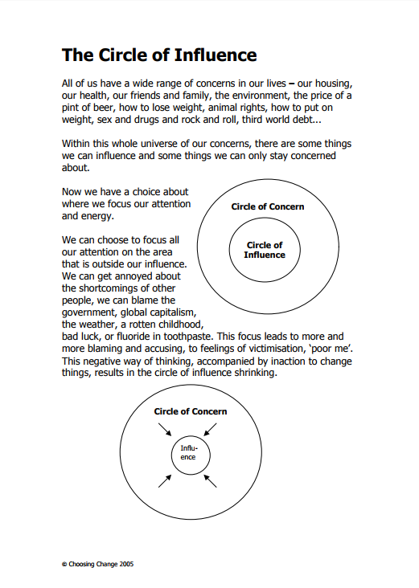

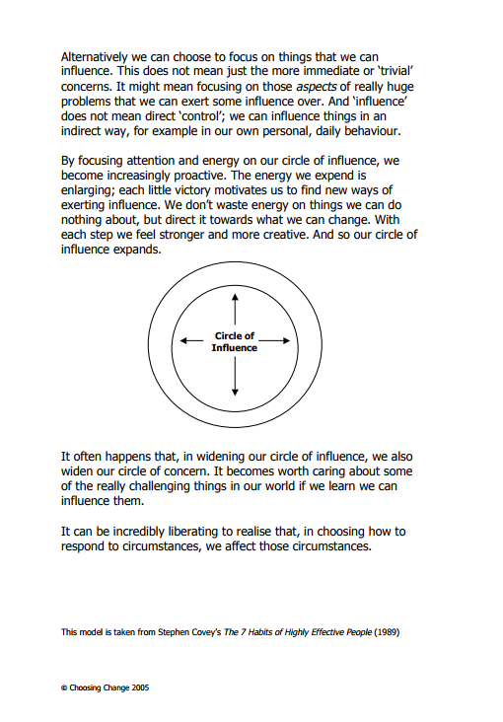

Make time to look after yourself and manage stress
It's important to look after yourself as well as your children. Being a parent isn’t always easy. It can feel hard if you're tired, stressed and unhappy.
Being a parent is the most wonderful and possibly the most difficult role you will have. It isn’t always easy and sometimes it can prove challenging. Remember nobody is perfect and nobody gets it right all the time.
Looking after a child can be hard work. Most parents feel negative emotions from time to time. These feelings are normal. It is important to manage feelings like anger and frustration so you can enjoy being a parent and have a safe, happy home for your child. Stressed parents are more likely to shout or use harsh punishments like smacking.

Try to set aside time for yourself
If you get a break to relax then you are more likely to be able to cope with everything. Take 10 minutes to have a bath, read a magazine or talk to a friend. Don’t spend time feeling guilty about the jobs that “should be done” when your child is asleep. Use some of this time to relax and do something you enjoy.
Try to eat well. This can be difficult for busy parents but the Change4Life (External link) has lots of ideas for simple and quick recipes and tips to stay fit and healthy.

Get together with other parents and their children
Your child will enjoy the company of another child and you will enjoy some adult conversation. There may be groups in your area where you can meet other parents and where your child will have some fun. Your Family Information Service will be able to tell you what’s on in your area. You can contact them by telephone on 0300 123 7777. The Family Point website (External link) also has information on services and activities in your area.

Anger
Most parents have times when they feel tested to their limits. Sometimes parents have trouble controlling their emotions and reactions. They may feel stressed about personal, medical or financial problems.
Learning to manage your anger will be beneficial to your health and your relationship with your child. If you lose your temper and lash out in anger you may hurt your child, even if you don’t mean to.
Try to get to know your own body’s signals for when anger is building up. Act before it gets out of control. These might be:
- clenched jaw
- fists tensed
- pounding heart
- feeling hotter.
If you feel anger getting the better of you it may help to:
- Stop and count to 10 before you act. That 10 seconds may help you calm your emotions.
- Try to breathe out the tension. Try to breathe out longer than your breathe in. Anger can make you breathe in more than out.
- Take some time out. Leave the room briefly, phone a friend, play your favourite music. Ask a friend or family member to care for your baby or child for a while so you can have time to yourself.
- Work it off. Exercise can help you deal with stress-related anger. Try swimming, walking, running or yoga. You can put your child in their push chair and go for a walk to let off steam.
- Ask yourself "Is it really worth getting angry about?" Is it about what your child has done or is it about feeling stressed?
- Think it through. Are there some things that wind you up more than others? Are there ways of avoiding those situations?
- Try not to bottle things up. It may help to talk it over with a friend or family. Or talk to other parents – it can be helpful to share experiences and tips.
Think whether there are some underlying feelings making you angry. If you feel angry in spite of everything you have tried, it may be worth getting some advice. It may help talking it through with a counsellor or getting some advice on managing your anger. You could speak with your GP about this or talk to the Family Information Service for services in your area. Alternatively you may find these helplines useful:
- C.A.L.L. Helpline (External link) 0800 132 737 (24 hour service) - Community Advice and Listening Line - (or text ‘help’ to text 81066). This is a confidential helpline which offers emotional support on mental health and related matters.
- Samaritans (External link) on 08457 90 90 90 (confidential 24 hour service), Email: jo@samaritans.org. You can get in touch about anything that’s troubling you, no matter how large or small the issue.
If you feel like you might hurt your child, ask for help from your health visitor or GP. By getting help, you will be doing the best thing for your child, your family and yourself.
It’s OK to ask for help.
Nobody gets it right all the time. It may help to talk things over with family or friends. If you are worried about feeling stressed, low or depressed talk with your health visitor or GP. Don’t be too critical of yourself. There is no such thing as the perfect Mum or perfect Dad.

If you are worried about feeling stressed, low or depressed talk with your health visitor or GP.

Stress Busting
Take a deep breath

Self-care – look after yourself, full cup

Exercise – let out energy

Healthy Eating

Get plenty of sleep

Good routines

Deal with problems on the spot – don’t bottle up your feelings

Make a plan of action – divide problems up into small ‘bite sized’ steps

Prioritise – focus on the most important things

Do the worst thing first – get it out of the way

Talk to someone – A problem shared is a problem halved

Distraction – do something to take your mind off what you are worrying about

Avoid Must’s and Should’s – Work out what is reasonable for you to achieve and be happy with this

Get out of a rut – do something different

How have I dealt with this before?

What advice would you give to a friend if they were in your shoes?

Situations out of your control – Accept that there are things in life that we can’t change
Stress - The BIG 5 Challenges


- What are the chances…?
(How much of your money
would you bet on it happening?)



- What is the worst thing that
could happen?
(Put the lid on it)



- Am I right to think that…?
(Weighing the evidence)



- Will this matter in 5
years’ time?



- What is this worth?
(Is life too short?)


Live in the Present …not in the past or future

If we worry about the past we are dwelling on things we cannot change.

If we worry about the future we are worrying about things that may never happen.

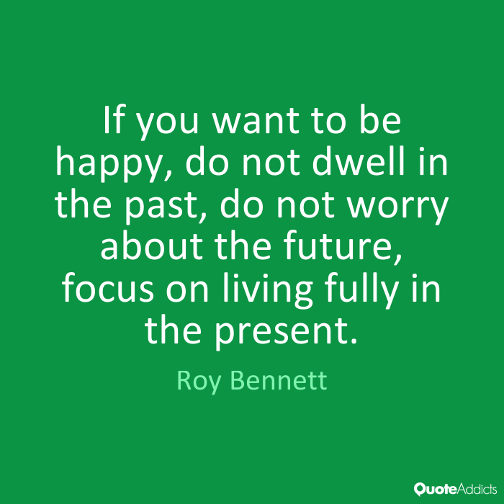

Vicious Cycle of Anxiety

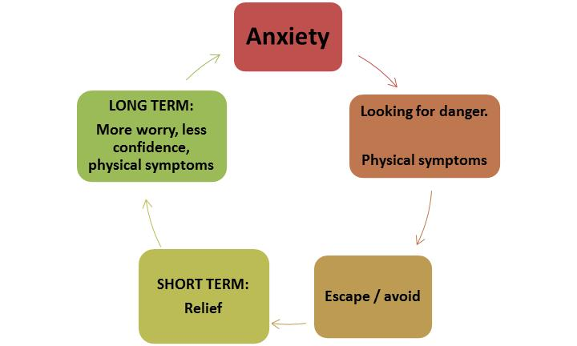

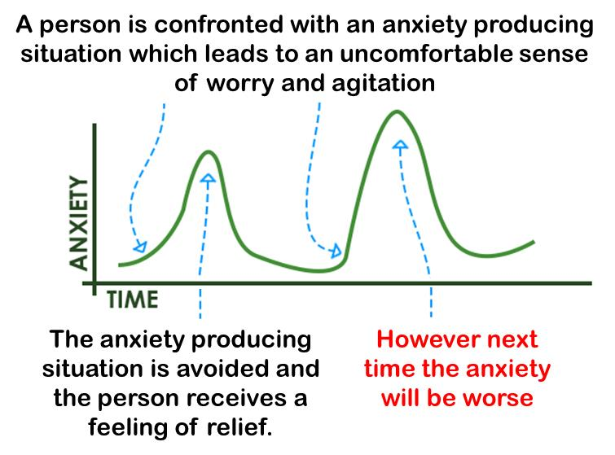

Breaking the Cycle of Anxiety

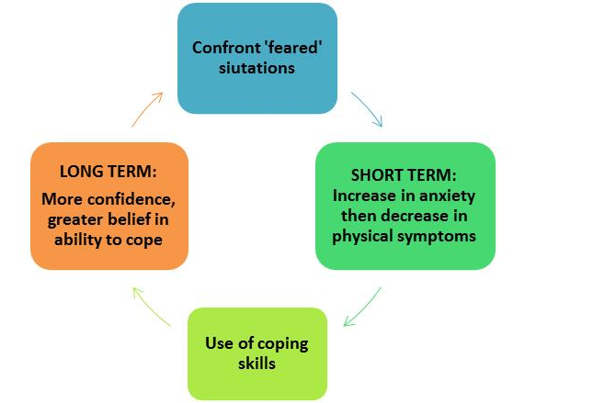

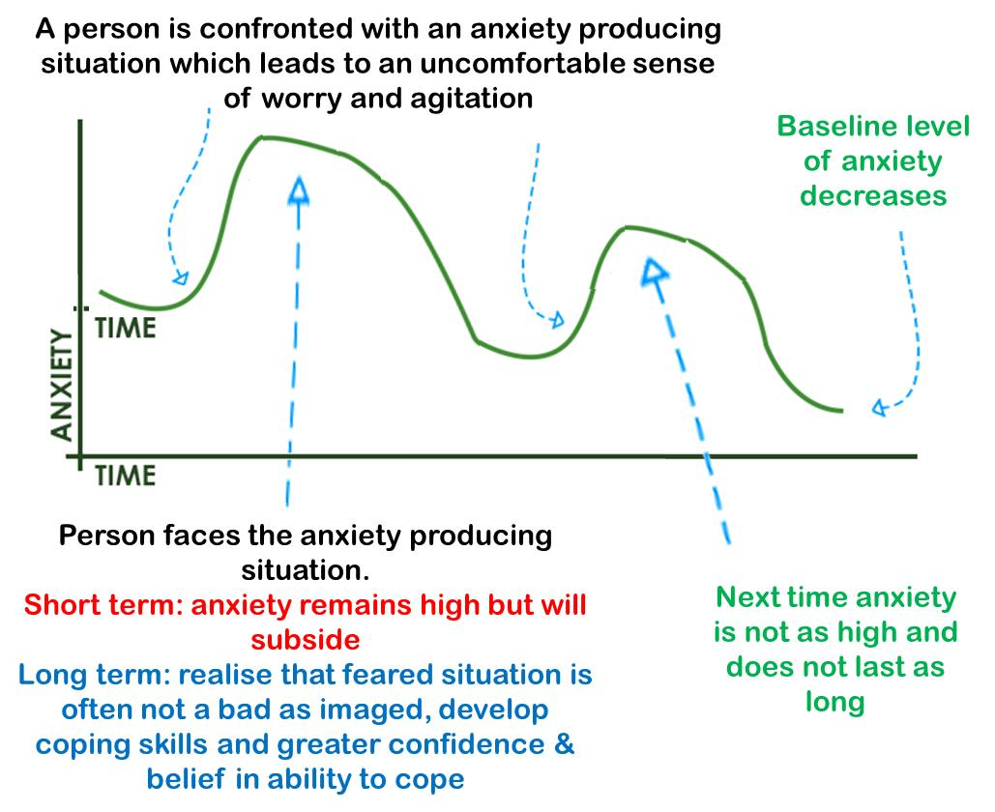
Reversing the Cycle

